 |  | Closed Point of  Dispensing (POD)  Functional Exercise  Putting the Closed POD Plan into Action
  Facilitator’s Guide

Contents
Instructor Preparation i
About the Functional Exercise i
Exercise Overview ii
Prepare to Conduct the Exercise iv
How to Use this Facilitator Guide vii
Exercise Materials viii
Instructor Materials List viii
Simulation Materials viii
Exercise Set-up 1
Facilitate Exercise Set-up 1
Welcome and Introduction 2
Introductions and Goal 2
What is a functional exercise? 2
Exercise Guidelines and Roles 3
Exercise Objectives 3
Today’s Plan 4
Scenario Assumptions 4
What would happen if…? 4
Phase 1 • Notification 6
Respond to Notification Alert 6
Phase 2 • Activation 7
Respond to Activation Alert 7
Phase 3 • Closed POD Set-up and Briefing 9
Brief all Volunteers and Set Up 9
Phase 4 ● Dispensing 11
Dispense using all Relevant Methods 11
Phase 5 ● Stand-down 13
Perform Stand-down 13
Wrap Up 14
Evaluation 14
Next Steps 14
Appendix ● Next Steps Worksheet 15

Instructor Preparation
“I think the three most important points are planning, response, and debriefing, as well as making sure you have all the right players at the table. You have to make sure to be prepared for the event before it happens, instead of just reacting.”  ~Bob DeVries, Chief, Kingman (Arizona) Police Department | About the Functional Exercise  Once your property has performed a tabletop exercise, you are ready to “play out the plan” with this functional exercise. After your property conducts this functional exercise, the next step will be to practice the plan with your local DOH and community partners. Expect to make mistakes and learn by doing.  Use this guide to plan, prepare, and facilitate the functional exercise with your property’s Closed POD team and designated “role players” – volunteers who play the role of recipients.

Exercise Goal
The goal of the functional exercise is to test all operational functions of the Closed POD Plan and increase the level of confidence enacting the plan. Specifically, your property will test:
- Command Team direction and control
- Decision-making processes
- The effectiveness of plans, policies, procedures, and roles
- Incident Command structure and communication effectiveness
- Allocation of resources and personnel to adequately meet the emergency situation

Exercise Overview
This interactive exercise is designed to test the functionality of your property’s Closed POD Plan. The functional exercise differs from the tabletop exercise in a few fundamental ways:
- It is designed to be realistic, portraying an appropriate amount of tension or stress that would be part of a real emergency situation.
- It is interactive, so that the Closed POD team responds in real time to a staged scenario with “live” recipients playing a role.
- Your property’s Closed POD Plan is practiced by carrying out the plan using practice resources and equipment.

Exercise Objectives
The Closed POD Team will:
- Respond to the Notification alert.
- Respond to property Activation alert by mobilizing and preparing the property and volunteers and transferring medications.
- Brief all volunteers and set up for dispensing.
- Enact medication dispensing using all relevant dispensing methods (those listed in the property’s plan).
- Ballroom
- Associate (Manager and Associate Pick-up)
- Room Service
- Scaled-back
- Perform the stand-down procedure.

Roles
The functional exercise involves the Closed POD Command Team, Volunteers, role players, a facilitator, and evaluators. The function of each role is as follows:
- Command Team. Plays out their planned roles/tasks and makes key decisions.
- Volunteers. Respond as they would in a real emergency based on their planned roles/tasks, and respond to the “recipients.” Select Volunteers according to the property’s Closed POD Plan.
- Role Players. Participants who represent recipients and ad-lib as necessary to simulate real life possibilities. Select volunteers to play various kinds of recipients. The role players are needed when the group is ready to dispense medication.
- Facilitator. The Back-up Coordinator plans and directs the exercise so objectives are met. If momentum slows down, s/he helps facilitate to move the exercise along. S/he also will conclude the exercise, begin the evaluation period and make sure all exercise feedback is captured to be able to write the After Action Report.
- Evaluators. Observe the exercise, provide input to the After Action Report, and provide constructive feedback that helps the property improve its plan and learn from the exercise.
Clarify these roles with participants in the introductory phase. See page 3.

How it Works
The intent of this exercise is to simulate a real life situation as much as possible. To this end, keep your briefings brief and your cues clear and direct.
The general facilitation pattern of this functional exercise falls into four stages.
- Use the PowerPoint presentation to set up the scenario and brief participants on how the exercise will progress.
- Interject timeline prompts, role play the DOH contact, cue role players just in time, and observe for process flow.
- Monitor the interaction and progress. Facilitate as needed to move the exercise along so that the group meets the exercise objectives. Adjust pace as needed.
- Conclude the exercise and facilitate the evaluation debrief.

Prepare to Conduct the Exercise
Before you deliver this functional exercise, make sure you have completed the following:
- Know the Closed POD Plan and Planning Kit. Part of what this exercise tests the use of documents that will enable participants to perform their roles. Ensure Planning Kit documents are available (e.g. all Briefings and Job Action Sheets are printed).
 | - Read this Guide. Read this guide thoroughly to familiarize yourself with the exercise planning, preparation, and facilitation needs. Know the process, understand desired outcomes, know your facilitation role, and be prepared to help participants get back on track as needed.
- Invite the DOH to attend. Invite your local emergency preparedness partners to attend this exercise. If the DOH is unable to participate, provide them with an After Action Report upon exercise completion. This communication will allow them to review your activities and assist your property with recommendations and corrective action planning.
- Plan the exercise schedule. Ensure you allow enough time for the exercise. Most exercise planners allow four to five hours.
- Notify your property of the exercise. Make necessary arrangements with department management and staff that will allow participants to play out their roles as realistically as possible without interrupting business or alarming guests.
- Arrange medication transfer materials for the exercise. Check with your local DOH to determine if the hotel can borrow materials such as skids, boxes of medication, bottles, patient information, etc. Alternatively, create your own exercise materials by using boxes of salt/pepper shakers, paper products, candy or the like that can simulate medication transfer, storage and dispensing. If Patient Information Packets are not available, simulate packets with paper folders. If the Medical Materials Transfer form is not available, mock up a form. Stage these materials prior to the exercise.
- Verify all Closed POD supplies and signage are ready. Ensure that signage and supplies (listed in Closed POD Plan) are available and stored in their designated areas.
- Assign a note-taker. Prior to the exercise, decide who will capture key take-away information. Document key discoveries and tasks that require follow up and/or alteration to your property’s Closed POD Plan (See the Appendix for a worksheet).

Suggestions for Facilitator
This session is designed to be facilitated by the Closed POD Back-up Coordinator.
- Review this entire guide and add your own notes as you see fit.
- Confer with your local DOH as you see fit, to answer any questions or concerns you may have prior to the exercise.
- Use a “parking lot” during the evaluation debrief. If questions arise that are unknowable at the time, place them in the “parking lot” to tackle later. Flip-chart all unanswerable questions and research answers. For example, you may need to consult a community partner such as the local police.
- Follow up after the exercise. Make sure to adapt the property’s Closed POD Plan and communicate any updates to your Command Team and the DOH.
- Schedule the exercise. Ensure you allow enough time for the exercise. Most planners allow 4 – 5 hours. You may wish to begin the exercise early in the morning with a continental breakfast so that inactive participants can eat while they listen and observe. Decide whether to begin the exercise at the Notification or Activation phase.
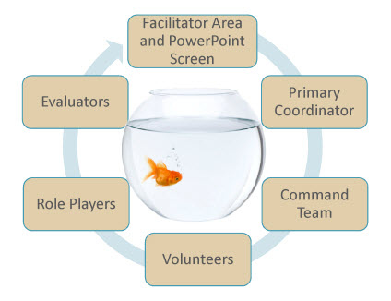 | Room Preparation  Use the property’s ballroom dispensing area for the exercise. Set up in the property’s staging area in a U-shape with enough room in the center space to begin the simulation.  - Arrange the room space as indicated on the left.  - Design enough space in the middle that the Primary Coordinator and Command Team can role play their roles in the center while others observe and take notes. This design is often called a fish bowl formation.  - The group will break from this formation when the exercise enters the Set-up and Briefing phase.  - The group will return to this formation to evaluate and debrief at the end of the exercise.  A few additional preparation pointers include:  - Use nametags that show not only participant’s name but their Closed POD role.  - Use a white board or flipchart for group documentation (such as the “parking lot”).  - Have a copy of the ballroom layout design to validate ballroom dispensing set-up.  - Use this formation to test all dispensing methods.
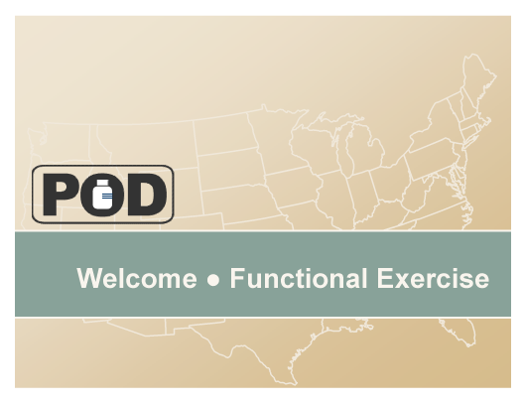  Slide [Number]   | How to Use this Facilitator Guide  This guide contains suggested scripting, which appears in a plain Roman font. The scripting helps guide you through the main points. It also provides a framework of direction for you to facilitate the exercise.  - Directives are not meant to be said aloud. They provide direction to you, the facilitator.  Directives are formatted like this, in bold italics.  - Thumbnail slide images are shown in the left column when it’s time to display a new slide. The slide number is included. (See the example at left.)  - Some slides require multiple clicks to play a simple animation. Slides requiring multiple clicks display the number of clicks at the top right of the screen, in a small mouse icon (shown at left).
Scenario Prompt  Role Play | Icon  The following icons will help you identify certain types of facilitation. (see icon at left):  - Scenario icon signals you to interject a condition or direction into the scenario and/or move timing along.  - Role play icon indicates that you will play a role in the scenario.

Exercise Materials

Instructor Materials List
In addition to this Facilitator’s Guide, you’ll need the following materials:
- Closed POD Functional presentation (PowerPoint file)
- Your property’s Closed POD Plan
- Closed POD Communications Matrix
- Ballroom Layout Design diagram

Simulation Materials
As part of the exercise the Coordinators and participants are responsible for accessing and distributing Closed POD materials, signage, and supplies. Their ability to do so is part of this exercise.
In order to have a more realistic simulation, in addition to the materials that participants will use as part of the exercise, you will need to gather the following materials and stage them appropriately for the exercise.
- Skids to transfer medication boxes
- Boxes of medication
- Individual Bottles of Medication
- Patient Information Packets
- 2-way radios (all Coordinators)
- Name tags
- Medical Materials Transfer (from the DOH or a mock form)
- Medication Screening Form

Exercise Set-up

Facilitate Exercise Set-up
Welcome people as they enter the room. Assign an assistant to ensure the following as people enter:
- Each person has a name tag with their name and role clearly printed.
- Ask people to sit together by role function.
- As they enter the room, prepare role players to play their role (see page 12).
- Make sure each person knows his/her role and where to go in the room.
Before you begin the PowerPoint presentation, verify that participants are grouped according to their role, sitting in a semi-circle, with space in the middle to act out their roles and tasks.

Welcome and Introduction
Slide 1 | Introductions and Goal  Welcome participants to the session. If introductions are appropriate, make them now.  Deliver a few opening remarks.  - If you are in this room, you are an important part of our property’s Closed POD Plan.  - As part of this Closed POD team, you are playing an important role helping us test and validate our property readiness in the rare case of a biological attack in our city.  - Today’s exercise will help us all understand our level of readiness and allow us to improve our plan as necessary.
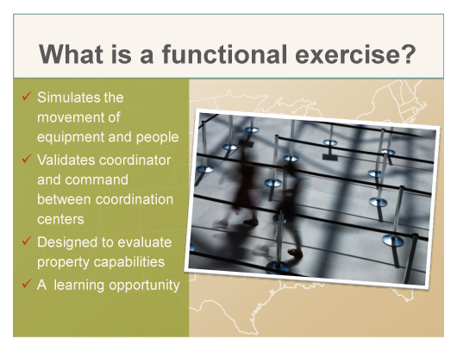  Slide 2 | What is a functional exercise?  Explain the functional exercise.  A functional exercise:  - Presents a hypothetical emergency situation so that the group can act out the plan as if the scenario were really happening.  - It examines and validates the coordination, command, and control between various coordination centers.  - It is not a measure of individual performance. We are looking at our ability to perform as a group. Consider this exercise group practice.  - It is also another learning opportunity for our property so that when we perform a functional exercise with DOH we are confident, coordinated, and ready to perform this process to the best of our ability.
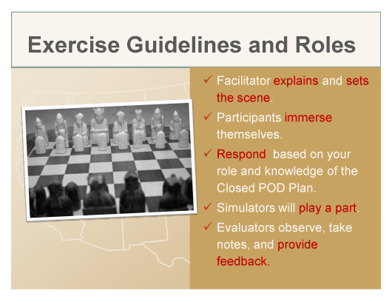  Slide 3 | Exercise Guidelines and Roles  Review the functional exercise guidelines. Briefly describe the areas that the group will use for the exercise and those that are “off limits” due to business activity.  - In just a moment, I will set up a scenario that will prompt us into action.  - When needed, I will also deliver prompts to you to initiate action.  - After the presentation sets up the scenario, we’ll begin the simulation at the Notification alert.  - Begin action in the center space and move out as your role dictates.  - Your job is to play out your role to the best of your ability, as if this situation were real.  - There are also “role players” or volunteers who will play the part of recipients (associates, registered and special function guests, contractors/vendors).  - Our evaluators are here to give us feedback on our ability to perform this plan in the event of an emergency. Evaluators, you will likely need to divide up and move with the action so you can observe all the moving parts.  - We’re going to do our best, and with that said, this is our opportunity to find potential gaps and/or make mistakes so we can fix them prior to an emergency situation.
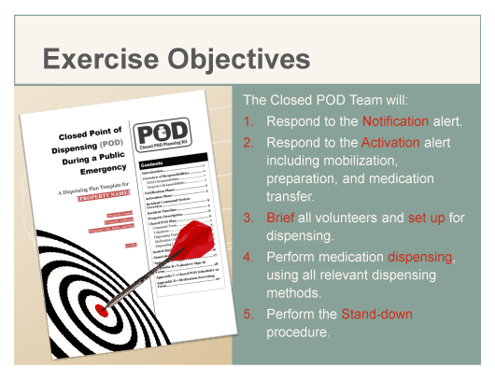  Slide 4 | Exercise Objectives  Read the objectives.  - These are the exercise objectives that we hope to achieve by the end of this exercise.  - Does anyone have any questions about what we want to accomplish?
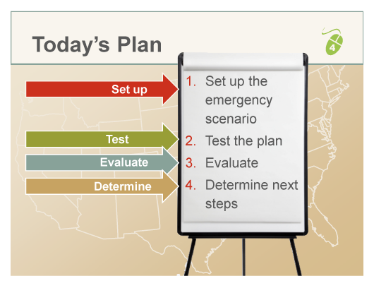  Slide 5 | Today’s Plan  Review the plan and mention any housekeeping details such as breaks, bathrooms, food service, etc.  - This session is scheduled to take about __ hours [4 – 5 depending on number of participants and your property’s dispensing methods].  - In a moment, I’ll kick off the exercise by setting up the scenario.  - From there, your job will be to respond as you would in a real life situation.  - The “role players” will play their parts as different kinds of recipients.  - As the exercise progresses, I will call timing, cue people as needed, and make sure that we complete all the objectives. Again, you respond as is appropriate for your role.  - At the end of the session, we’ll go through the evaluation, and plan next steps.
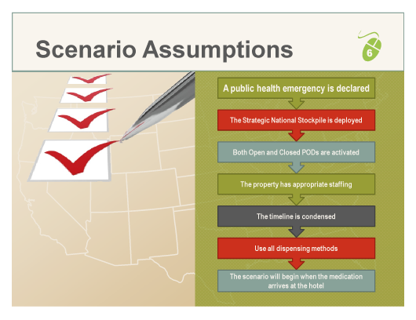  Slide 6 | Scenario Assumptions  Talk through the scenario assumptions.  - For the purposes of today’s exercise, we’ll make the following assumptions.  - We’ll assume that the emergency is critical enough to declare a public health emergency.  - We’ll assume that the emergency is large enough to deploy the Strategic National Stockpile.  - We’ll assume that both Open and Closed PODs will be activated.  - We’ll assume our property has appropriate staffing on the day of event.  - We’ll use an artificial timeline and condense time to move the activity along.  - We’ll play out all possibilities in our plan so that we act out all dispensing methods (including Scaled-back if included in the plan) through the Stand-down phase.
 | - We’ll assume the starting point for this exercise is when the medication arrives at our hotel.

Check for Understanding
- Are there any questions about what we will do today or what part you’ll play before I present the scenario?
Let’s dive into our scenario and then we’ll get right into action.
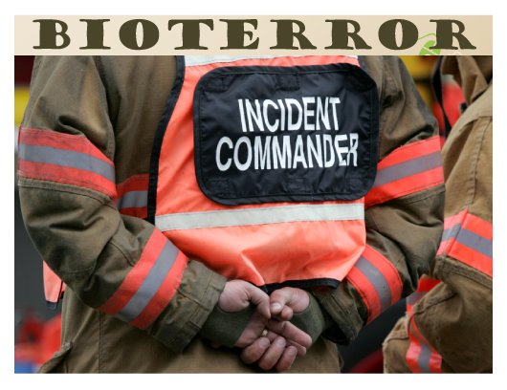  Slides 7… | What would happen if…?  Set the stage by creating a “real life” story with the slide imagery. The first slide produces a sound to create dramatic effect. Use your voice to build on this “drama” and to convey tension that will help draw participants into the storyline and imagine that an emergency situation is at hand.
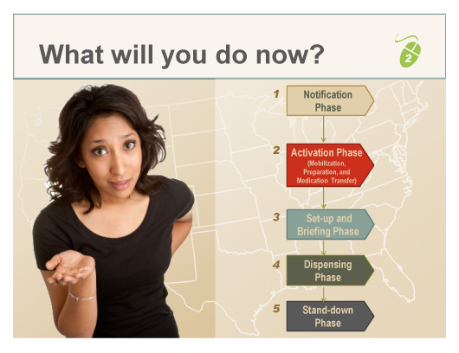  …through 16 | What will you do now?  Prompt the action with this slide.  Use the phase sections below to prompt action, facilitate timing, and cue people as needed.  Refrain from telling people what to do; rather, ask questions or facilitate the environment so people can figure things out for themselves. Take notes as you go to add to the evaluation debrief at the end of the exercise.

Phase 1 • Notification

Respond to Notification Alert
Ask the group to walk through the steps after receiving a Notification alert, role-playing through the steps as realistically as possible. Tell them:
- What is the first step?
Look for the following:
- Primary Coordinator responds to Notification alert, notifies Command Team, and determines the actual (day of) dispensing population.
- Primary and Business Coordinators determine space availability.
Scenario Prompt | Use the following questions/cues as needed:  - Who begins the action?  - Who’s communicating with whom?
DOH | If the DOH is not there, play the part of the DOH contact person receiving the dispensing population head count.

Phase 2 • Activation

Respond to Activation Alert
Start the Activation phase.
Scenario Prompt | Once space readiness has been established, observe and facilitate for the following:  - Primary Coordinator responds to the Activation alert, notifies the Command Team to report to the facility, and briefs the Command Team.  - Command Team recruits and assigns Volunteers.  - Business Continuity Coordinator clears designated dispensing areas.  - Designated personnel notify the dispensing population; HR Coordinator reports readiness.  - Security Coordinator secures and prepares the property for medication transfer.
DOH | Play the role of the DOH contact person delivering the Activation alert. Give instructions to the Primary Coordinator regarding medication transfer. Tell him/her that the medication will arrive within four hours.
Scenario Prompt | Prompt medication transfer. Announce to the group the medication has arrived.
Observe the group mobilize and prepare for medication transfer.
- Security Coordinator picks up or receives medication, transports medication to secure storage, verifies amounts, and reports receipt.
Use the Communication Matrix to validate key communication signals are sent and received.
Note if the following Closed POD Planning Kit documents are used by the appropriate person:
- Primary Coordinator uses the Command Brief (to Command Team) and Coordinators’ Job Action Sheets (JASs).
- If picking up medication, the Security Coordinator uses Medication Pick-up Authorization Letter.
- Security Coordinator uses Medical Materials Transfer form from the DOH.
- If using the Manager or Associate Pick-up method, the Associate Dispensing Coordinator hands out Medication Screening Forms to associates.
- Designated personnel, hands out notice (sample letter) to inform guests of the emergency and plans to dispense medications.

Phase 3 • Closed POD Set-up and Briefing

Brief all Volunteers and Set Up
Once medication has arrived, the Primary Coordinator has notified the DOH of the medication transfer, and the HR and Business Continuity Coordinators have established volunteer and space readiness, the Set-up and Briefing phase can begin with volunteer sign-in.
Scenario Prompt |  | If the Primary or HR Coordinators do not prompt volunteer sign-in, give a prompt to initiate sign-in.
Observe the group sign-in, briefings, and set up of all planned dispensing areas.
- Volunteers sign in, put on vests and IDs, and complete Medication Screening Forms.
- Primary Coordinator briefs all volunteers.
- HR Coordinator assigns/deploys Volunteers.
- Command Team briefs respective teams, explains and hands out JASs.
- Volunteers set up dispensing area(s).
- Security team transfers medication from storage or staging area to dispensing areas.
- Volunteers enter dispensing area and take medication, HR Coordinator reports readiness.
Use the Communication Matrix to validate key communication signals are sent and received.
Note if the following Closed POD Planning Kits documents are used by the appropriate person:
- Primary Coordinator gives the Command Brief to all volunteers.
- Coordinators give the Command Briefs to their teams and hand out the JASs.

Phase 4 ● Dispensing

Dispense using all Relevant Methods
After volunteers have received their medication and the Primary Coordinator is ready to open the ballroom dispensing area, dispensing can begin.
Scenario Prompt | Prepare several “recipients” to go through ballroom dispensing with the following prompts:  - Ask a simulator to fill out a Medication Screening Form with more than 10 names listed.  - Ask a simulator to fill out a Medication Screening Form with eight names listed, yet none are designated as a child under eight years old.  - Ask a simulator to fill out a Medication Screening From with “Scruffy” (a dog/cat) listed.  - Ask a simulator to fill out a Medication Screening Form with illegible writing.  - Ask a simulator to walk in “off the street” (e.g., this simulator is not a registered guest or associate).  - Ask a simulator to speak only in Spanish (or a language other than English).  - Ask a simulator to act sick with symptoms.  - Ask a simulator to act very old with trouble walking.  - Ask a simulator to demand more medication than is listed on his/her form.  - Ask a simulator to threaten a Dispenser if s/he does not give him/her more medication.
Check that all planned dispensing methods are working properly in coordination ⎯ Ballroom, Associate (Manager and Associate Pick-up), and/or Room Service.
- Volunteers dispense medications
- Logistics Coordinator reports medication inventory status
 | Use the Communication Matrix to validate key communication signals are sent and received.
Scenario Prompt | When participants have acted through all dispensing methods and prompts, prompt the Primary Coordinator to initiate a Scaled-back POD.  Check for the following:  - Configure and operate a scaled-back POD.  - Dispensing ends – Associate Dispensing and HR Coordinators signal end.

Phase 5 ● Stand-down

Perform Stand-down
If the Primary Coordinator does not announce the end of dispensing, use the following prompt to announce to the group that dispensing is complete.
Scenario Prompt | Announce to the group that there are no more recipients in line and dispensing is complete.
DOH | Play the role of the DOH giving the property permission to stand-down.
Observe the group break down, return equipment and supplies, gather unused medication, sign-out and debrief.
- Closed POD stands-down
- Security Coordinator takes inventory and reports
- Volunteers return the property to its original condition, Logistics team returns supplies
- Debrief and sign out

Transition
Conclude the exercise. Allow for a break if necessary and ask evaluators to prepare their comments for the exercise debrief.

Wrap Up
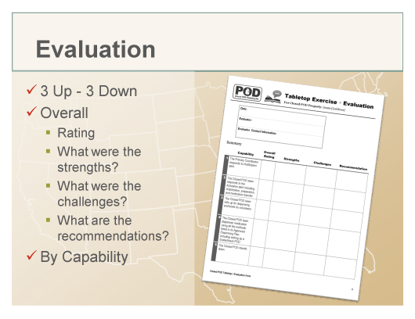  Slide 17 | Evaluation  Return to the PowerPoint presentation.  Ask the participants to provide three things that went well and three things that need improvement (“three up and three down”). Include your own observations.  Ask the evaluators to share their findings – both overall and in each capacity area.  - Rating  - Strengths  - Challenges  - Recommendations
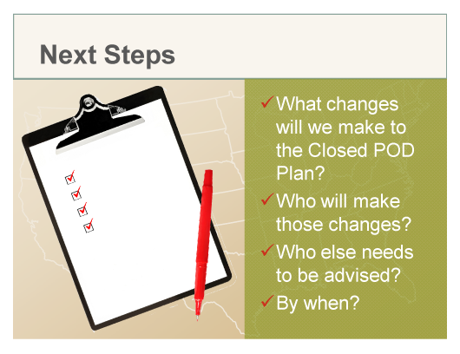  Slide 18 | Next Steps  With the group, determine next steps. Be clear about who will do what and by what date. Use the form in this guide’s Appendix to document To Dos.  Make sure to provide the DOH with any changes to your property’s Closed POD Plan.

Appendix ● Next Steps Worksheet
Action Item | Closed POD Plan Area (page #, section, etc.) | Who? | By When?

